SyntaxTreeHybrid Practice Assignment — Answer Key
Instructor use only. Do not distribute to students.

Exercise 1–4: Sample Sentence Answer Key
These are the New Orleans-themed sample sentences provided in the assignment. Students should create their own sentences, not copy these, but these serve as the model answers for the structural patterns.

Exercise 1: Simple Sentence
Sentence: Musicians play.
[S [NP [N Musicians]] [VP [V play]]]
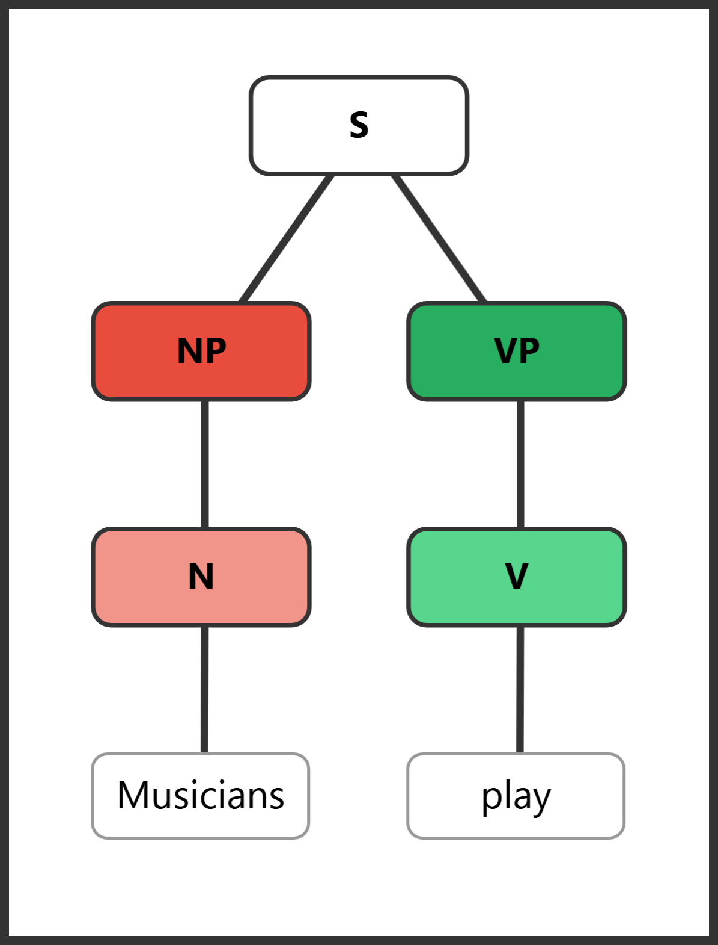
Exercise 1 diagram
Structure breakdown:
- S → NP + VP
- NP → N (Musicians)
- VP → V (play)

Exercise 2: Determiner + Adverb
Sentence: The streetcars move slowly.
[S [NP [DET The] [N streetcars]] [VP [V move] [ADVP [ADV slowly]]]]
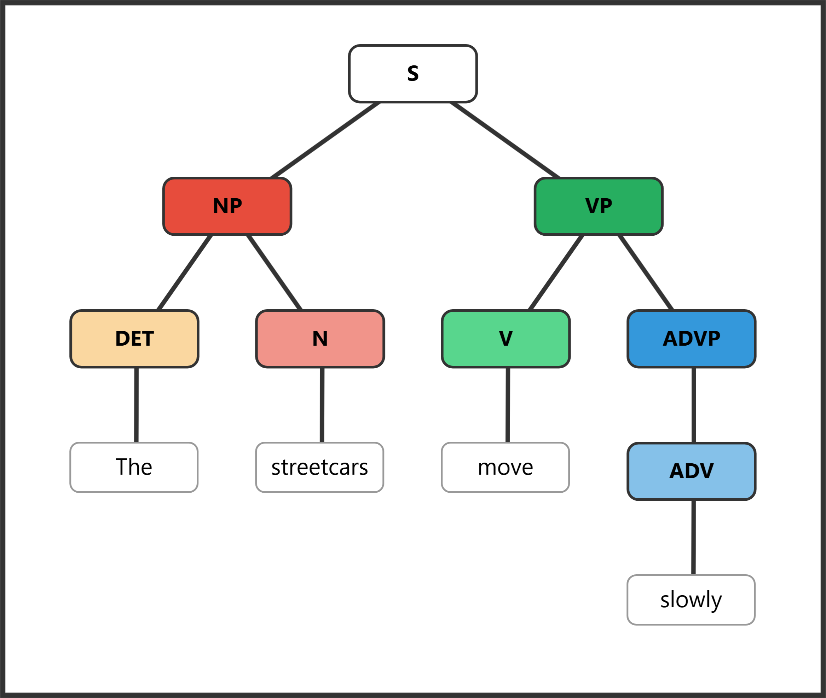
Exercise 2 diagram
Structure breakdown:
- S → NP + VP
- NP → DET (The) + N (streetcars)
- VP → V (move) + ADVP
- ADVP → ADV (slowly)

Exercise 3: Adjective Phrase + Prepositional Phrase
Sentence: Delicious gumbo simmers in kitchens.
[S [NP [ADJP [ADJ Delicious]] [N gumbo]] [VP [V simmers] [PP [PREP in] [NP [N kitchens]]]]]
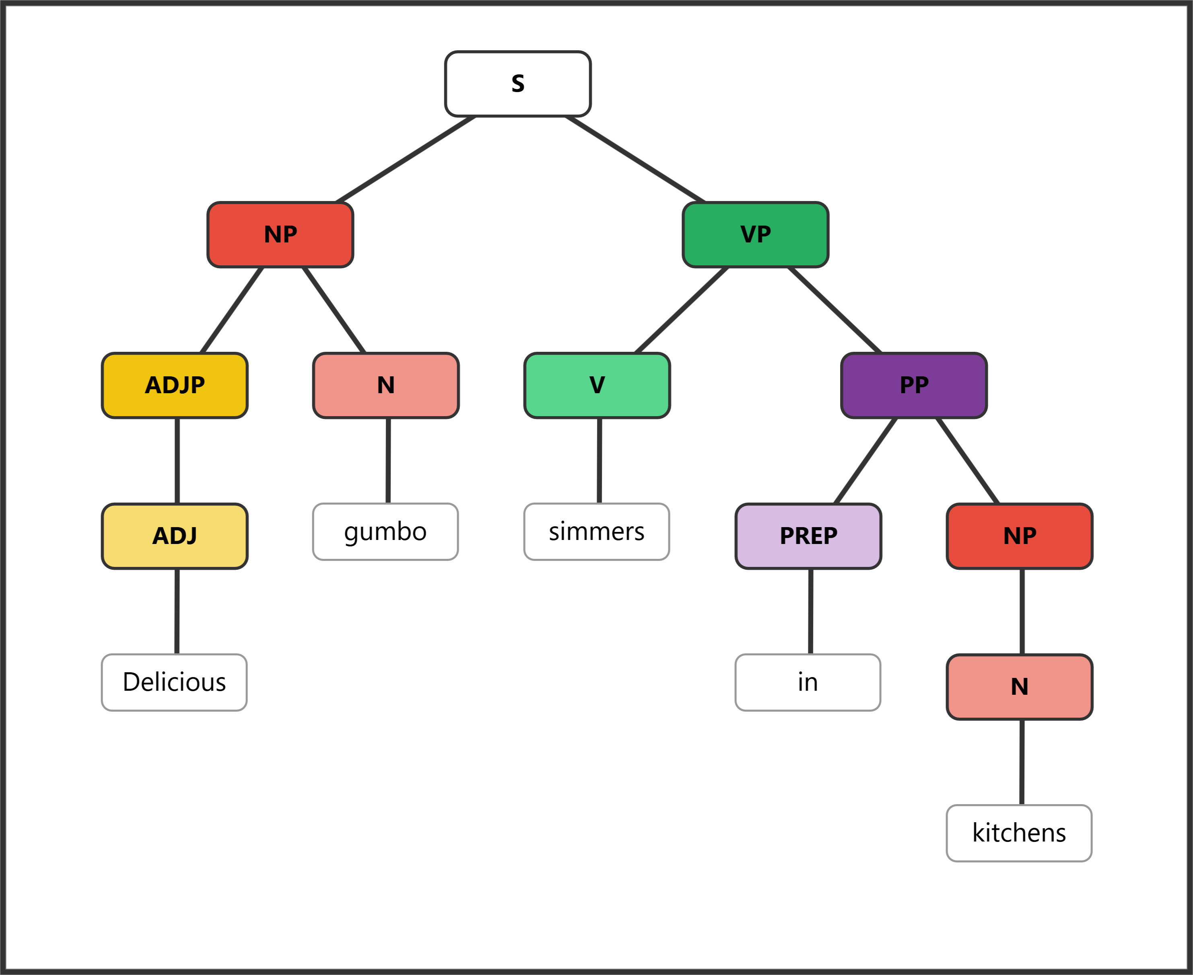
Exercise 3 diagram
Structure breakdown:
- S → NP + VP
- NP → ADJP + N (gumbo)
- ADJP → ADJ (Delicious)
- VP → V (simmers) + PP
- PP → PREP (in) + NP
- NP → N (kitchens)

Exercise 4: Nested Phrases
Sentence: Incredibly lively crowds dance quite energetically.
[S [NP [ADJP [ADVP [ADV Incredibly]] [ADJ lively]] [N crowds]] [VP [V dance] [ADVP [ADVP [ADV quite]] [ADV energetically]]]]
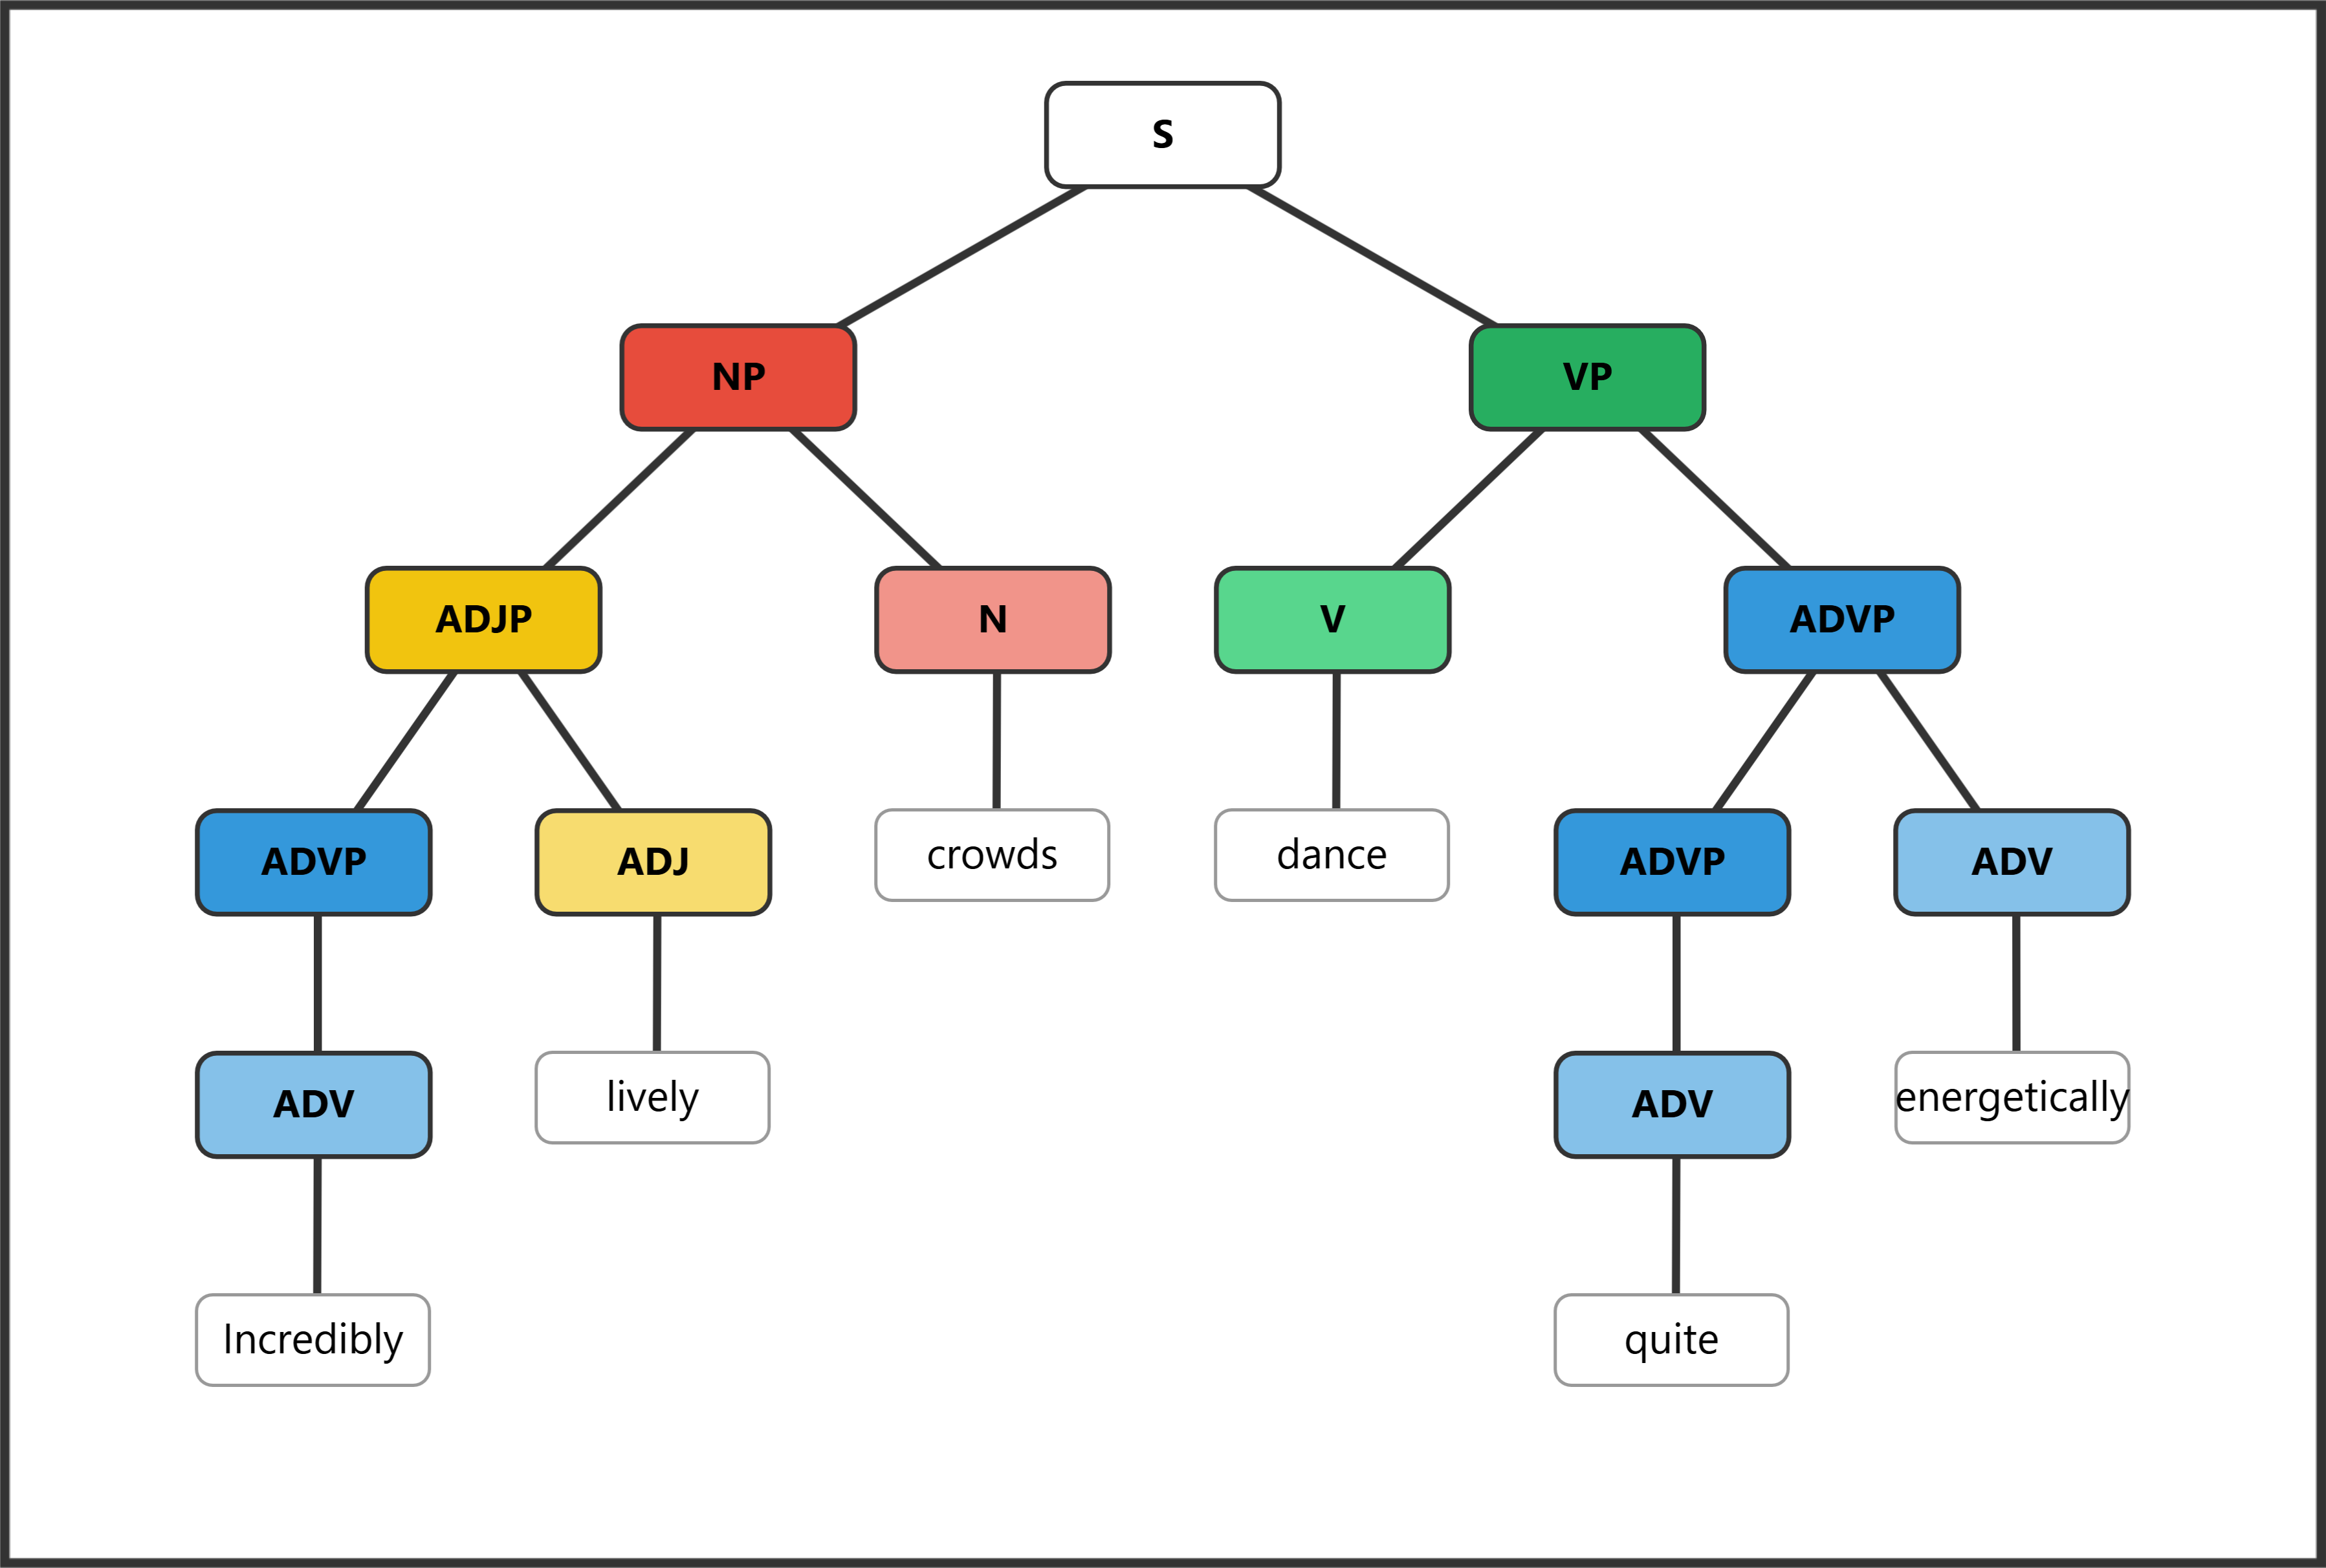
Exercise 4 diagram
Structure breakdown:
- S → NP + VP
- NP → ADJP + N (crowds)
- ADJP → ADVP + ADJ (lively) — the adverb Incredibly modifies the adjective
- ADVP → ADV (Incredibly)
- VP → V (dance) + ADVP
- ADVP → ADVP + ADV (energetically) — the adverb quite modifies energetically
- ADVP (inner) → ADV (quite)

Exercise 5: Diagram These Sentences — Answer Key

5a. Some very smart scientists fail quite frequently.
[S [NP [DET Some] [ADJP [ADVP [ADV very]] [ADJ smart]] [N scientists]] [VP [V fail] [ADVP [ADVP [ADV quite]] [ADV frequently]]]]
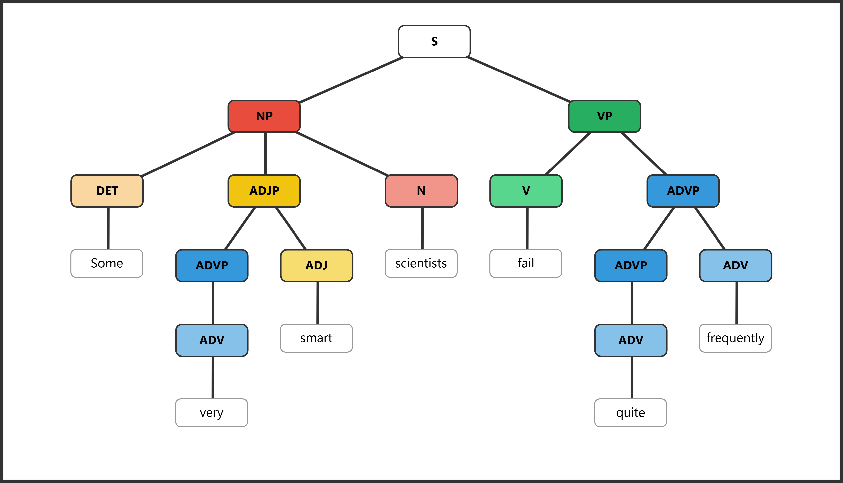
Exercise 5a diagram
Structure breakdown:
- S → NP + VP
- NP → DET (Some) + ADJP + N (scientists)
- ADJP → ADVP + ADJ (smart) — very is a degree adverb modifying smart
- ADVP → ADV (very)
- VP → V (fail) + ADVP
- ADVP → ADVP + ADV (frequently) — quite is a degree adverb modifying frequently
- ADVP (inner) → ADV (quite)

5b. The fool on the hill speaks so eloquently.
[S [NP [DET The] [N fool] [PP [PREP on] [NP [DET the] [N hill]]]] [VP [V speaks] [ADVP [ADVP [ADV so]] [ADV eloquently]]]]
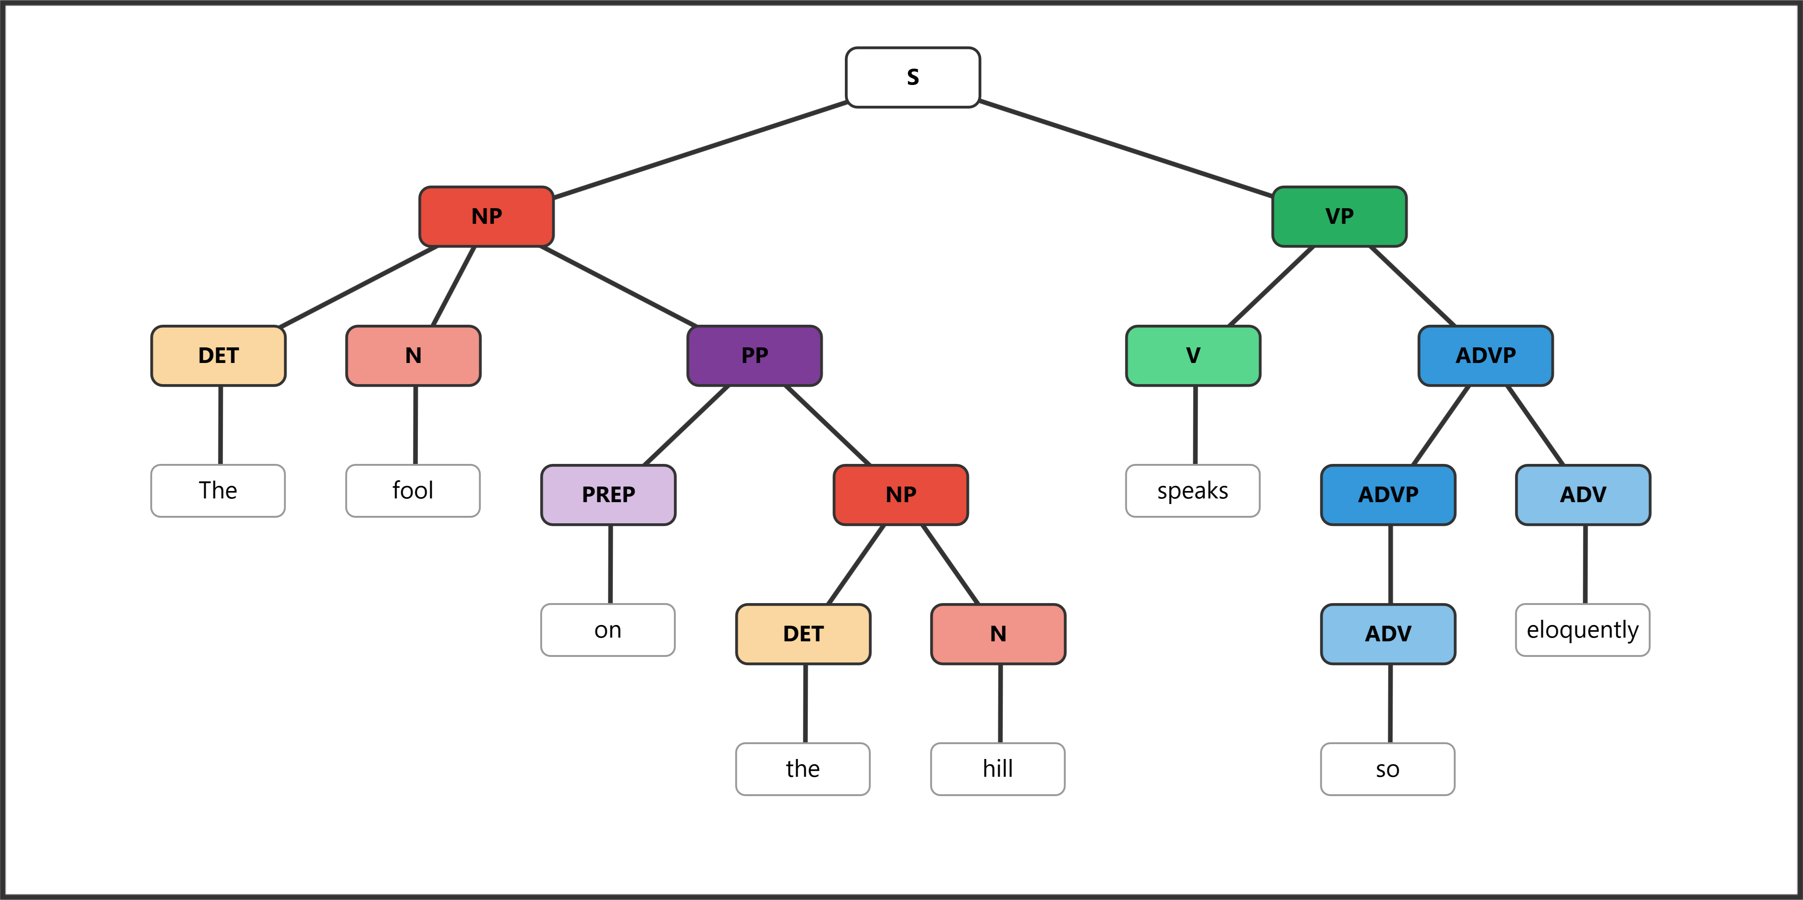
Exercise 5b diagram
Structure breakdown:
- S → NP + VP
- NP → DET (The) + N (fool) + PP — the PP on the hill modifies the noun fool
- PP → PREP (on) + NP
- NP (embedded) → DET (the) + N (hill)
- VP → V (speaks) + ADVP
- ADVP → ADVP + ADV (eloquently) — so is a degree adverb modifying eloquently
- ADVP (inner) → ADV (so)

5c. Terrible products often linger on the shelf.
[S [NP [ADJP [ADJ Terrible]] [N products]] [VP [ADVP [ADV often]] [V linger] [PP [PREP on] [NP [DET the] [N shelf]]]]]
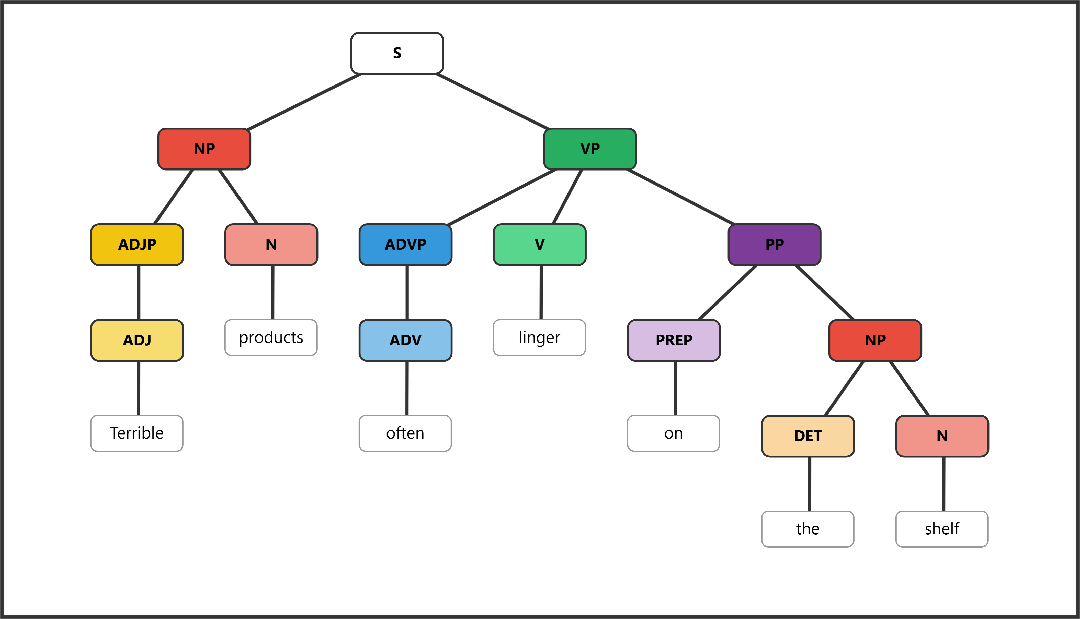
Exercise 5c diagram
Structure breakdown:
- S → NP + VP
- NP → ADJP + N (products)
- ADJP → ADJ (Terrible)
- VP → ADVP + V (linger) + PP — often is an adverb modifying the verb, placed before it
- ADVP → ADV (often)
- PP → PREP (on) + NP
- NP (embedded) → DET (the) + N (shelf)

5d. Extremely nervous teenagers sweat profusely on many first dates.
[S [NP [ADJP [ADVP [ADV Extremely]] [ADJ nervous]] [N teenagers]] [VP [V sweat] [ADVP [ADV profusely]] [PP [PREP on] [NP [DET many] [ADJP [ADJ first]] [N dates]]]]]
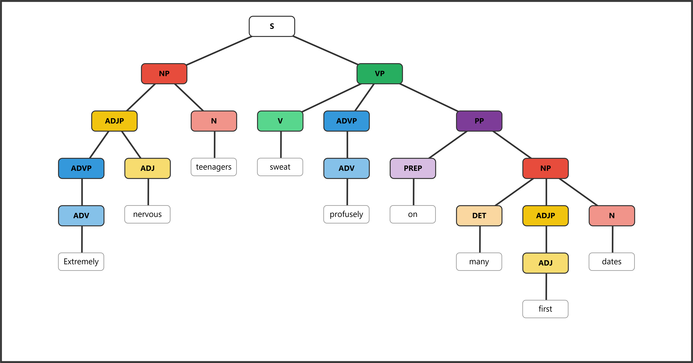
Exercise 5d diagram
Structure breakdown:
- S → NP + VP
- NP → ADJP + N (teenagers)
- ADJP → ADVP + ADJ (nervous) — Extremely is a degree adverb modifying nervous
- ADVP → ADV (Extremely)
- VP → V (sweat) + ADVP + PP
- ADVP → ADV (profusely) — manner adverb modifying sweat
- PP → PREP (on) + NP
- NP (embedded) → DET (many) + ADJP + N (dates)
- ADJP → ADJ (first)
Grading note for 5d: This is the most complex sentence. Key things to look for:
- Extremely should be inside an ADVP nested within the ADJP (modifying nervous, not teenagers)
- profusely should be in its own ADVP within the VP
- many functions as a determiner (DET), not an adjective
- first is an adjective inside an ADJP modifying dates
- The PP on many first dates attaches to the VP (adverbial), not the NP

